

**BOOKLET 4b**

###### Mathematics Methods 3&4

# GRAPHS OF DERIVATIVE FUNCTIONS:

2018

B: **GRAPHS OF DERIVATIVE FUNCTIONS:**

1. **Sign of the gradient – Positive if the part of the graph is rising from left to right**
2. **Negative gradient if it is descending from left to right.**
3. **At turning point or point of inflection the gradient = 0 i.e at turning point or point of infection**
4. **Horizontal line has gradient of zero.**

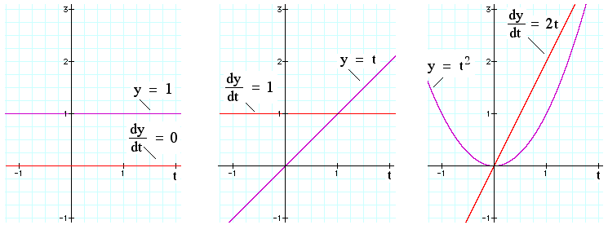

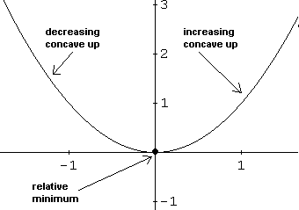

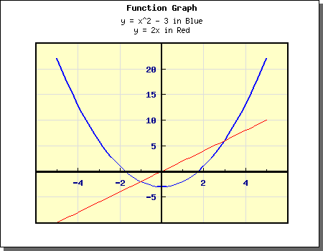

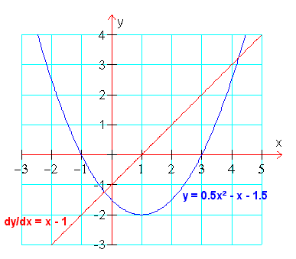

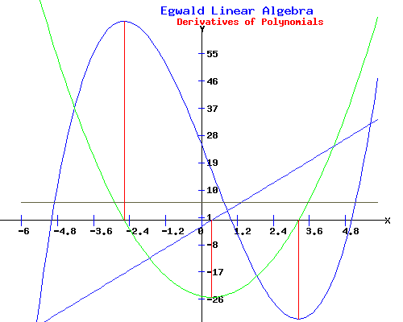

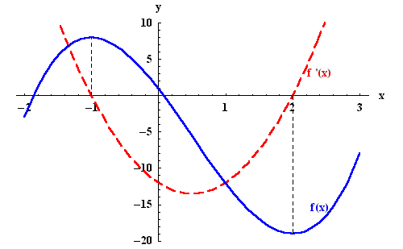

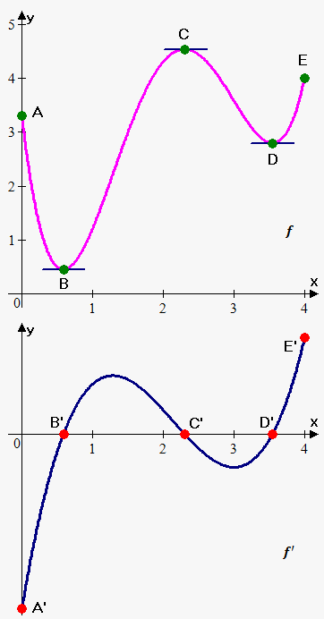

**Summary**

* A turning point on  occurs when, . This is at a point when the curve is horizontal.
* A point of inflection on  corresponds to a turning point on the  and a horizontal intercept on 
* A horizontal intercept on  corresponds to either a turning point or a horizontal inflection point on 
* A turning point on  corresponds to an inflection point on. A turning point which is also a horizontal intercept is also a horizontal intercept on  corresponds to a horizontal inflection point on 

**EXAMPLE:**

The following diagram is for the function. Determine the x – coordinates of the turning point(s0 and inflection point(s) of 

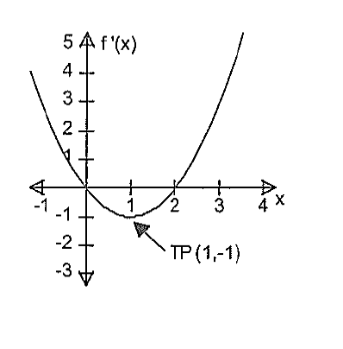

**Solution:**

 intersects the x – axis at *x* = 0 and *x* = 2. Hence  has turning points at

*x* = 0 and *x* = 2.

 has a turning point at x = 1. Hence  has an inflection point at *x* = 1.

**EXERCISE 2:**

**Question One.**

Given the sketch of , determine the x – coordinates of the turning point(s) and inflection point(s) of 

**(a) (b)**

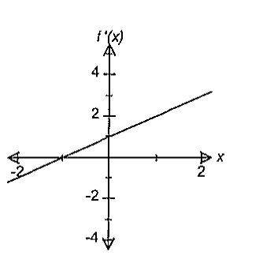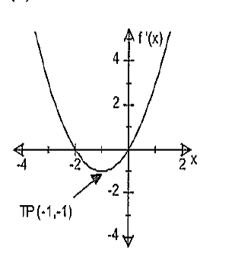

**(c) (d)**

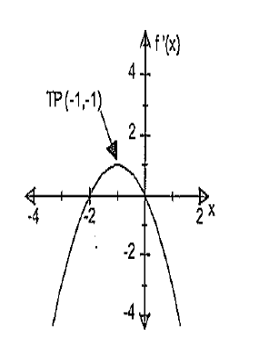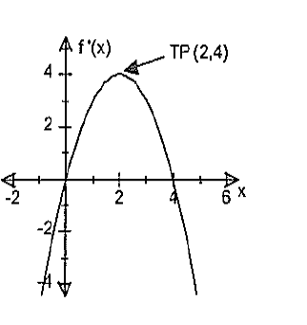

**(e) (f)**

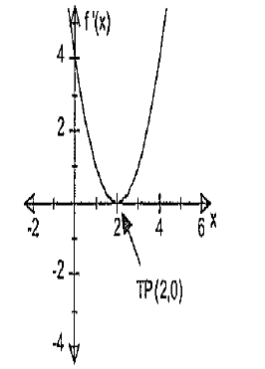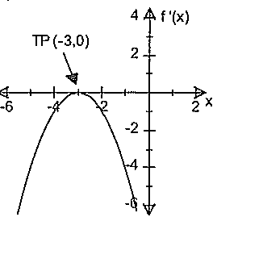

**(g) (h)**

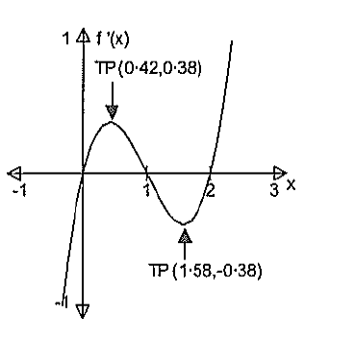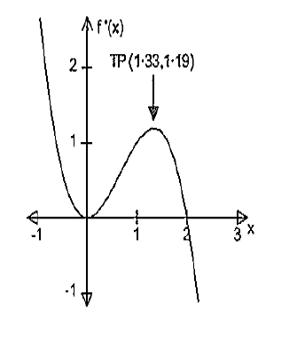

**Question Two**

Given the sketch of, determine the x – coordinate of point(s) of inflection of  where it/they exist(s)

**(a) (b)**

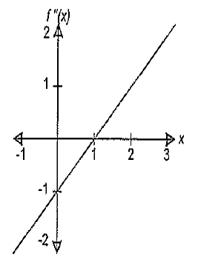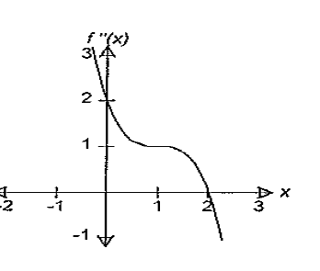

**(c) (d)**

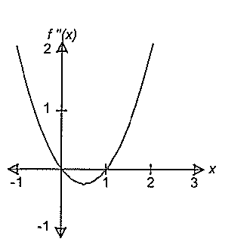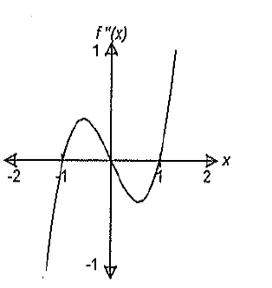

**(e)**

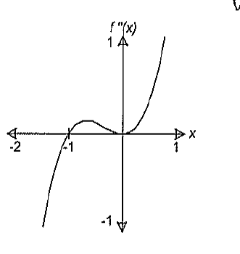

**CURVE SKETCHING WITH DERIVATIVES:**

**Important features to note when drawing graphs of derivative functions**

1. ***y* intercept is when *x* is equal to zero. i.e **
2. ***x* – intercept is when *y* is equal to zero**
3. **Sign of the gradient – Positive if the part of the graph is rising from left to right**
4. **Negative gradient if it is descending from left to right.**
5. **At a point of inflection the second derivative is and gradient = 0 i.e at turning point or point of infection**

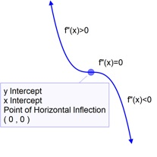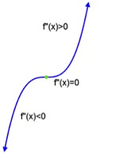 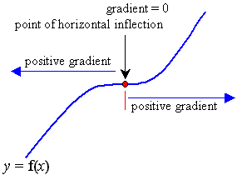

1. **At the turning point the gradient is zero**

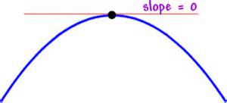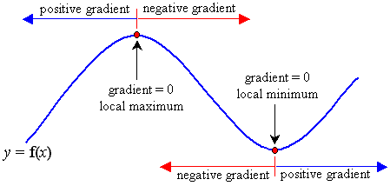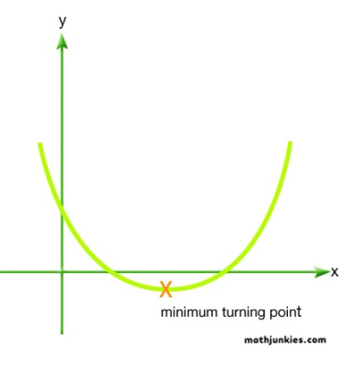

1. **If second derivative is zero, then we have a point of inflection i.e **
2. **If second derivative is greater than zero, then the original graph graph us concave up i.e minimum i.e **

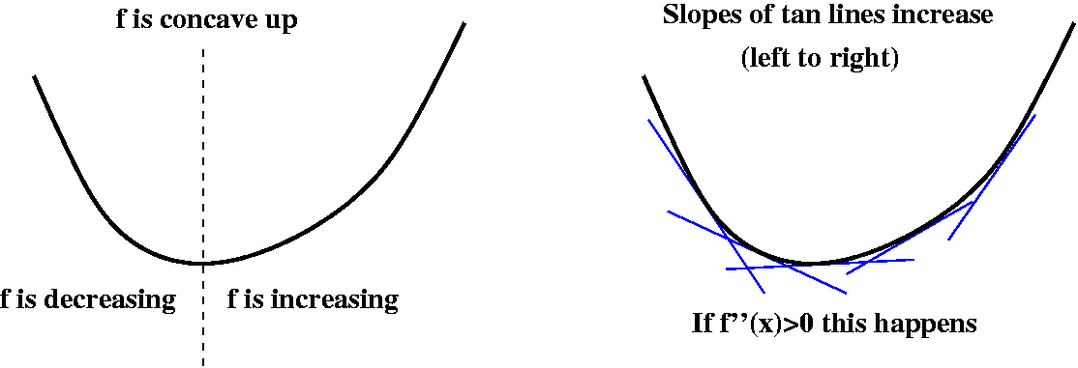

1. **If the second derivative is less than zero then the original graph is concave down i.e i.e maximum**

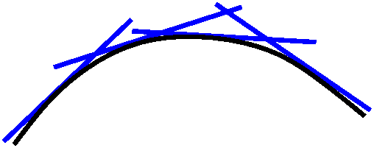

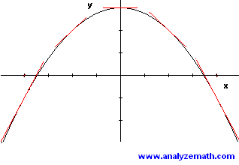

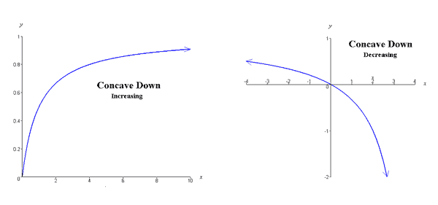

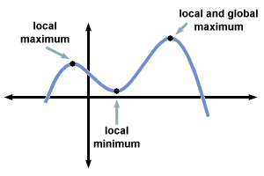

**EXAMPLE**

**Given the sketch of** , sketch a possible graph of 

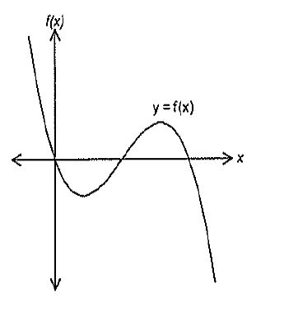

**Solution:**

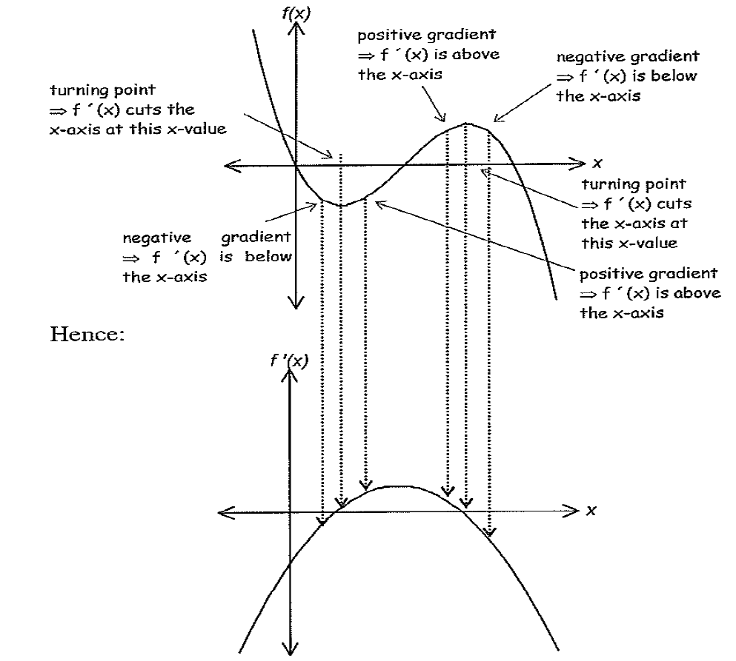

**EXAMPLE**

**Given the sketch of** , sketch a possible graph of 

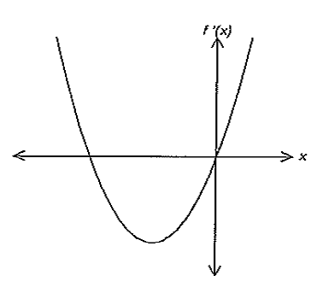

**Solution:**

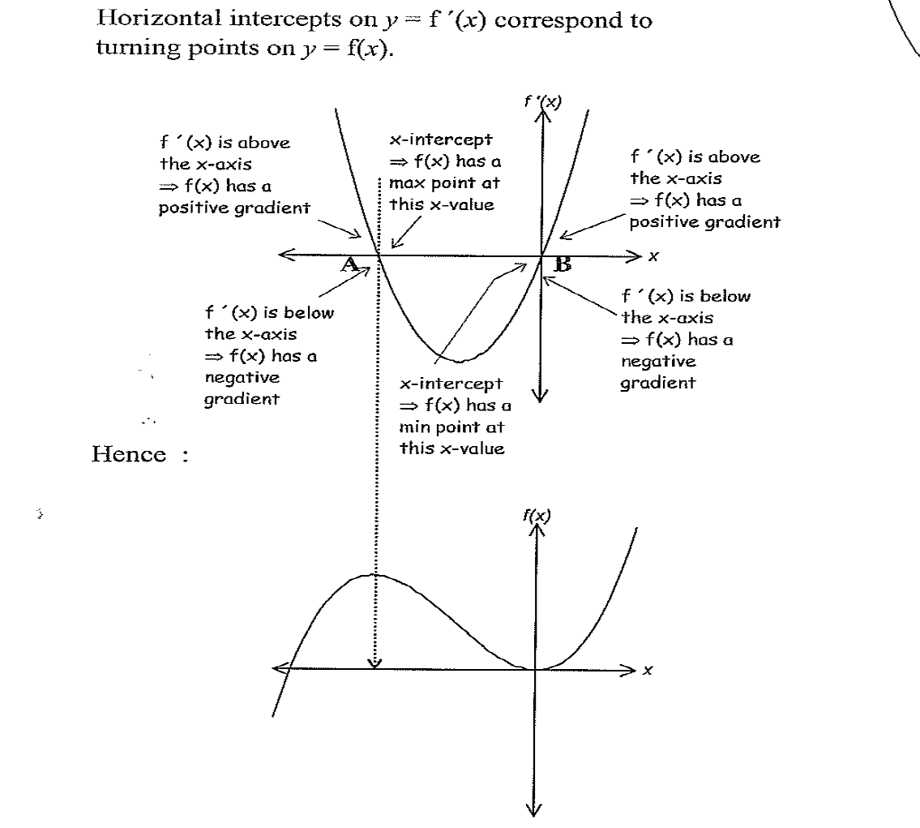

**Question Three:**

**Given the sketch of** , sketch a possible graph of 

**(a) (b)**

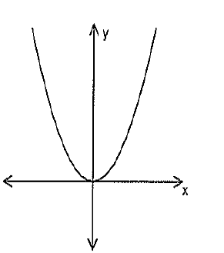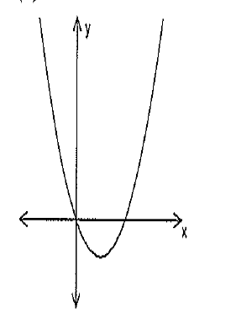

**(c) (d)**

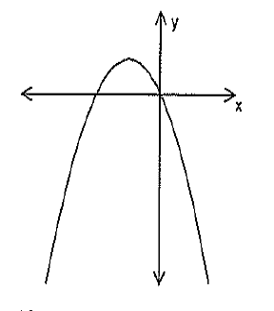 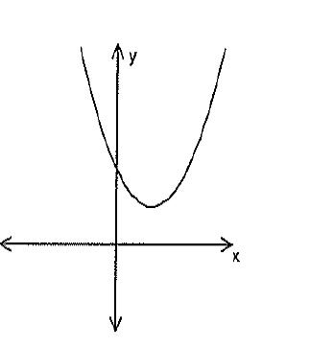

(e) (f)

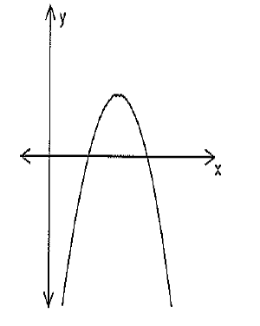 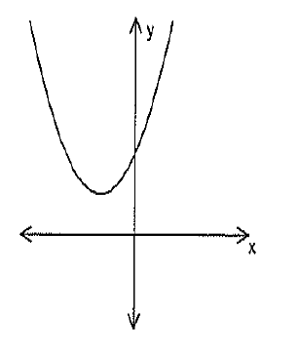

(g) (h)

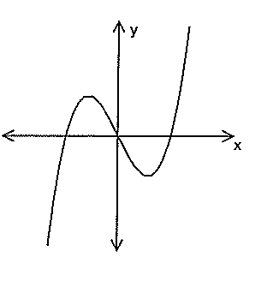 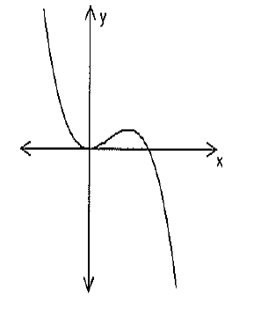

(i)

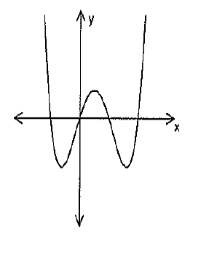

**Question Four**

**Given the sketch of** , sketch a possible graph of 

